[ Insert official UPAEP logo ]
UPAEP · Decanato de Ingenierías
EVIDENCE — US15-T10
Document the actuator command API and polling protocol
SmartGreenAI: Cilantro Crop

1. Task information
Task ID | US15-T10
User Story | US-15 — Manually activate or deactivate irrigation
Sprint | Sprint 3 (2026-10-12 – 2026-10-30)
Week | Week 3
Responsible | Vicente Rocha Alfaro
Peer reviewer | Oscar Abraham Talavera Nava
Planned / actual hours | 1 h / 1 h
Completed on | October 30, 2026
Status | Done

2. Task description
Document the command, polling and acknowledgement endpoints, the command states, the polling interval and the timeouts so that the ESP32 firmware and US-26 (Sprint 4) can reuse the flow.

Actuator command API and polling protocol (docs/API.md)
docs/API.md — lines 198–280
#### Actuator command API and polling protocol (US15-T10)
The greenhouse never accepts inbound connections: the server queues commands and the device (ESP32 firmware or
simulator) **polls** for them, executes them and **acknowledges** them by reporting the new state. Manual control
(US-15), the automatic irrigation engine (US-16, source `AUTOMATIC`), the automation rules (FR-18) and accepted AI
recommendations (US-26, source `AI`) all use this same flow.
```
web / engine API (actuator_commands) device (every 5 s)
POST /actuators/:id/command ──► PENDING (expires_at = now + 60 s)
│ GET /devices/me/commands ◄──── poll
├──────► SENT (sent_at) ──────────────► execute relay / servo
│ POST /actuators/:id/state ◄─── { state, duration_min }
└──────► EXECUTED (executed_at) + actuator_events row (US-17)
not collected/confirmed before expires_at ──► EXPIRED (never delivered again)
```
**1. Queue a command — `POST /api/actuators/:id/command`** (user token, permission `actuators.command`:
Producer, Administrator, Super Administrator).
```json
{ "action": "ON", "duration_min": 3, "reason": "Soil looks dry" } // action ON | OFF; duration and reason optional
201 { "id": "cmd-…", "actuator_id": "ACT-PUMP-01", "action": "ON", "duration_min": 3, "source": "MANUAL",
"status": "PENDING", "requested_by": "usr-producer", "reason": "Soil looks dry",
"created_at": "…", "expires_at": "…(+60 s)", "sent_at": null, "executed_at": null }
```
| Error | When |
|---|---|
| `400 ERR_VALIDATION_FAILED` | unknown action; `duration_min` ≤ 0 or above the area's `max_duration_min` (default 10); the area is in **AUTOMATIC** mode; the actuator is deactivated |
| `401 ERR_AUTH_REQUIRED` | no token, expired token, or a device API key instead of a user token |
… (51 more lines)

3. Completion conditions
✓ Condition 1: Endpoints and payloads documented.
How it was verified: The three endpoints of the flow (queue a command, poll, acknowledge) are documented with their permission or API key, request and response payloads and errors. The payloads were captured from the running API with the same calls the firmware and the simulator make:
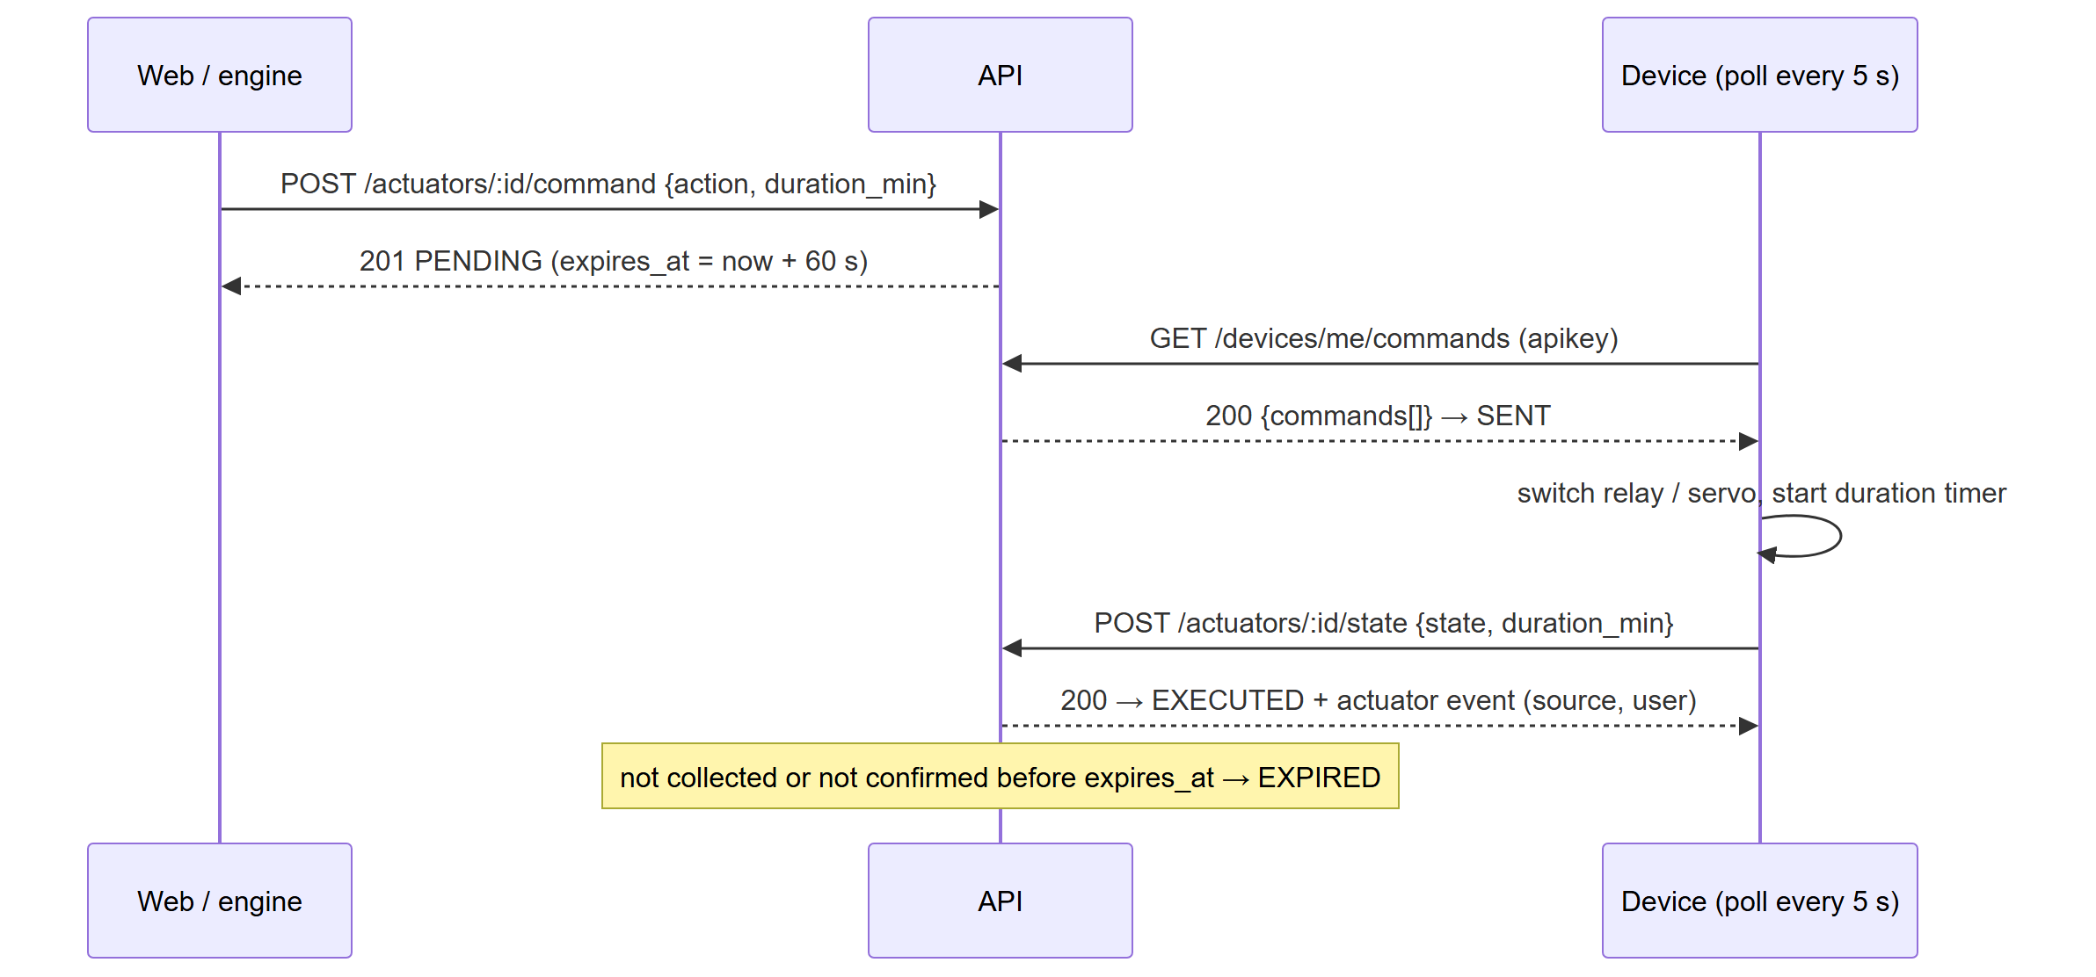
Figure US15-T10-1. Polling protocol between the API and the device. (US15-T10_Document_Actuator_Command_API_Polling_Protocol_1.png)
Protocol calls against the running API (queue, 409, poll, acknowledge, expiry) (attached: US15-T10_Document_Actuator_Command_API_Polling_Protocol_5.txt)
POST /api/actuators/ACT-FAN-01/command
Authorization: Bearer eyJhbG…
{
"action": "ON",
"duration_min": 1,
"reason": "US15-T10 protocol check"
}
→ HTTP 201 Created (12 ms)
{
"id": "cmd-ca5a57a8496f",
"actuator_id": "ACT-FAN-01",
"action": "ON",
"duration_min": 1,
"source": "MANUAL",
"status": "PENDING",
"reason": "US15-T10 protocol check",
"requested_by": "usr-producer",
"created_at": "2026-10-30T22:49:31.472Z",
"sent_at": null,
"executed_at": null,
"expires_at": "2026-10-30T22:50:31.472Z"
}
POST /api/actuators/ACT-FAN-01/command
Authorization: Bearer eyJhbG…
{
"action": "OFF"
}
→ HTTP 409 Conflict (20 ms)
{
"status": 409,
"code": "ERR_CONFLICT",
"message": "Another command for this actuator is still pending execution.",
"details": [
{
"field": "actuator_id",
"issue": "Command cmd-ca5a57a8496f is PENDING."
}
]
}
GET /api/devices/me/commands
apikey: sec_io…
→ HTTP 200 OK (11 ms)
{
"device_id": "dev-node-01",
"server_time": "2026-10-30T22:49:31.507Z",
"count": 1,
"commands": [
{
"id": "cmd-ca5a57a8496f",
"actuator_id": "ACT-FAN-01",
"action": "ON",
"duration_min": 1,
"source": "MANUAL",
"created_at": "2026-10-30T22:49:31.472Z",
"expires_at": "2026-10-30T22:50:31.472Z"
}
… (2 more lines in the attached file)
POST /api/actuators/ACT-FAN-01/state
apikey: sec_io…
{
"state": "ON",
… (104 more lines)

✓ Condition 2: Command states and timeouts documented.
How it was verified: Command states (PENDING, SENT, EXECUTED, EXPIRED, FAILED) and the timing are documented: polling every 5 s (firmware POLL_INTERVAL_MS), expiry 60 s (command.expiry_seconds), expiry check on every poll and every minute, actuator OFFLINE after 5 min, maximum 10 min per irrigation, engine every 30 s. Checked live: a command left without a poll for 62 s was EXPIRED and was not delivered.
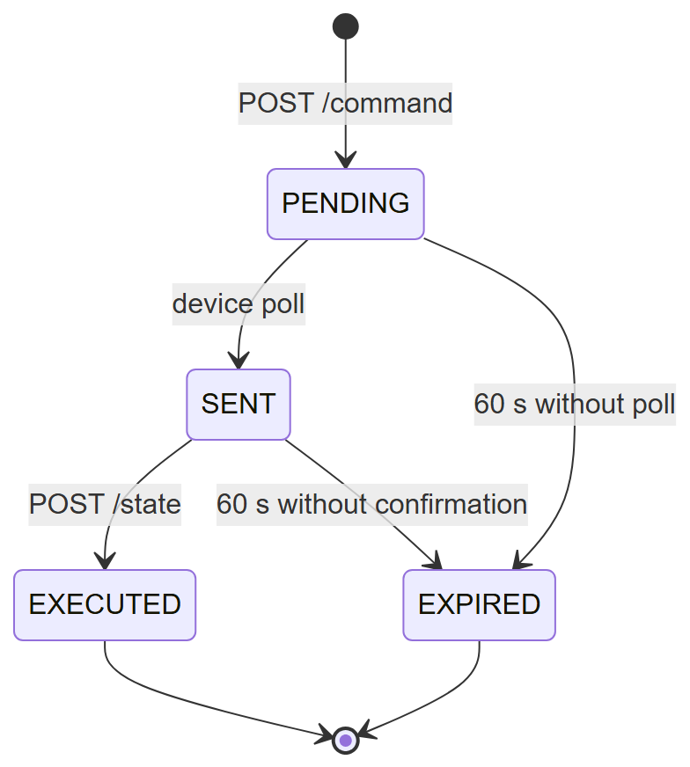
Figure US15-T10-2. States of an actuator command. (US15-T10_Document_Actuator_Command_API_Polling_Protocol_2.png)
Timeouts stored in system_parameters (running database) (3 rows; US15-T10_Document_Actuator_Command_API_Polling_Protocol_3.csv)
key | value | description
actuator.offline_minutes | 5 | Minutes without a state report after which an actuator is…
command.expiry_seconds | 60 | Seconds a command waits to be collected by the device bef…
device.offline_minutes | 5 | Minutes without contact after which a device is OFFLINE (…
SQL: SELECT key, value, description FROM system_parameters WHERE key IN ('command.expiry_seconds', 'actuator.offline_minutes', 'device.offline_minutes') ORDER BY key
iot/esp32_smartgreen/esp32_smartgreen.ino — lines 58–60
const unsigned long POLL_INTERVAL_MS = 5000;
const unsigned long HEARTBEAT_MS = 30000;

server/src/modules/commands/service.js — lines 188–201
async function expireStale() {
const result = await db.query(
`UPDATE actuator_commands
SET status = 'EXPIRED'
WHERE status IN ('PENDING', 'SENT') AND expires_at < NOW()
RETURNING id, actuator_id`,
);
if (result.rowCount) {
logSystem('WARN', 'commands',
`${result.rowCount} command(s) expired without being executed by the device.`);
}
return result.rowCount;
}

⚠ Condition 3 (pending team input): Reviewed by Oscar (US-16).
Pending: Oscar Abraham Talavera Nava must review the protocol section of docs/API.md and confirm it (team chat or meeting record). Then add the approval record to tools/evidence/board_sprint3.js (APPROVAL["US15-T10"]) and rebuild this document.
How it was verified: Review by Oscar Abraham Talavera Nava (owner of US-16, which reuses the flow for automatic irrigation).
✓ Condition 4: Evidence: API and polling protocol documentation.
How it was verified: API and polling protocol documentation (section above; docs/API.md in the repository).

4. Attached files
- US15-T10_Document_Actuator_Command_API_Polling_Protocol_1.png
- US15-T10_Document_Actuator_Command_API_Polling_Protocol_2.png
- US15-T10_Document_Actuator_Command_API_Polling_Protocol_3.csv
- US15-T10_Document_Actuator_Command_API_Polling_Protocol_4.sql
- US15-T10_Document_Actuator_Command_API_Polling_Protocol_5.txt

5. Traceability
Related requirements | FR-16, FR-17
Implementation | docs/API.md › Actuator command API and polling protocol
Verification | calls against the running API

6. Sign-off
Role | Name | Date | Signature
Responsible | Vicente Rocha Alfaro | October 30, 2026
Peer reviewer | Oscar Abraham Talavera Nava | October 30, 2026
Product Owner acceptance | Alexis Enrique Valle Parra | October 30, 2026

